ICT & Technology

Week 4 – Chapter 2

Evidence

Festival challenge: Counting people

Single button

**Problem 1:** 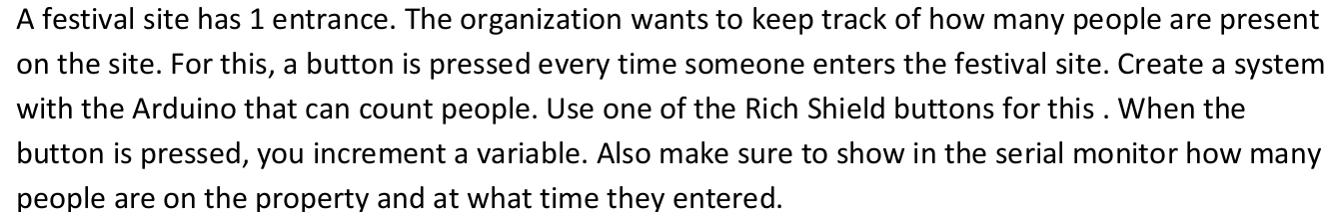

* Add a small delay after a button press has been detected. If the delay is chosen correctly, the button has already been released by the user when the program executes the next loop.
* Apply a delay() function in your program and choose the delay in such a way that when you briefly press the button, the variable is only increased by 1 and the program still responds quickly enough.

**Action:**

* I have defined the buttonPin which is one of the yellow buttons on the Arduino, buttonState which reads the state of the button and peopleEntered which is the amount of people that have currently entered the festival.
* In the loop() function I added an if statement which checks if the buttonState == LOW (the button is pressed).
* I added a delay(300) so that the peopleEntered increases only by one by the time the button has been released and then peopleEntered++ means one person is added.
* For the variable timePersonEntered I used the millis() function which counts the time since the Arduino started running
* Lastly, I print the information every time the button is pressed.

Link to the video of the Arduino:

<https://drive.google.com/file/d/14cvFlO2iqY35l4ydS1Tr1BwvvCJS-KyY/view?usp=drive_link>

**Reflection:** I had fun doing this assignment. I needed to use the internet to learn how to do some of the requirements in the assignment and it all worked out. I am satisfied.

**Decision:** My goal is to practice more with the Arduino.

Two button challenge

**Problem 2:**

* Prevent the number of festival visitors from becoming negative in the program.

**Action:**

* I added a second button buttonPinLeft and renamed the first button to buttonPinEnter, as well as buttonStateEnter and buttonStateLeave.
* I did the same thing I did for the first button but this time instead of increasing peopleAtFestival by 1, I decrease it by 1 (peopleAtFestival--).
* I added an if condition which checks if the people at the festival are not 0. If that is true, peopleAtFestival is decreased by 1. If it is false, the program prints “There are no people left at the festival and the peopleAtFestival does not decrease. This was my solution for preventing the number of festival visitors from becoming negative in the program.

Link to the video of the Arduino:

<https://drive.google.com/file/d/1LvbzD6QHkG-0hXC1UZROSeXXNugws4s0/view?usp=drive_link>

**Reflection:** It did not take me long to think of the solution for the number of visitors becoming negative. I had fun while doing this task.

**Decision:** My goal is to continue developing my problem-solving skills by doing more coding and experimenting with the Arduino.